16.36: 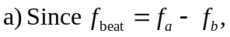 the possible frequencies are 440.0 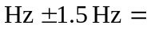 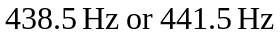 b) The tension is proportional to the square of the frequency. Therefore 